**Solve below assignment as per instructions-**

1. **List out highest priority process in the system**

**Ans :**

* To display information about processes used the **ps** command.
* To edit the output format of the ps command used –**eo** where –**e** is to select all process and –**o** is to define the output format.
* Sorted the **nice** collumn using (**--sort**) as a lower nice value means higher will be the priority.

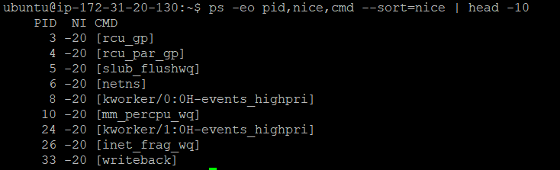

1. **Find the process which is sleeping in "wait" state.**

**Ans:**

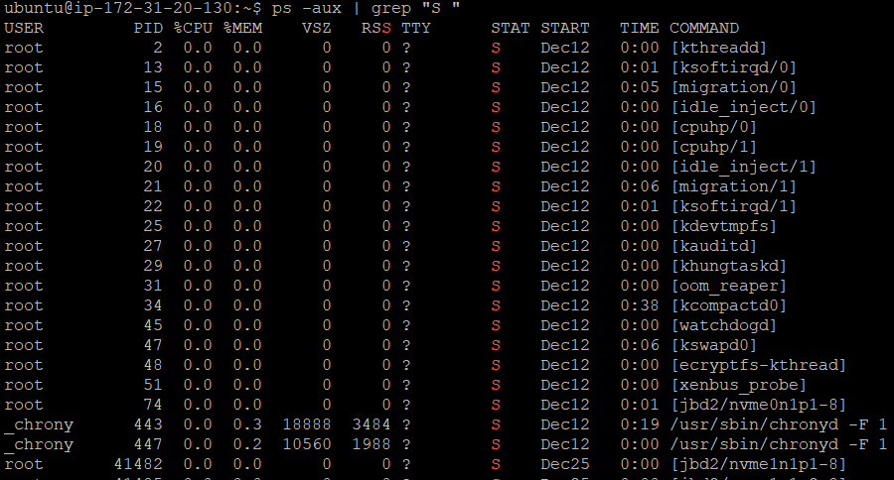

**3) Open terminal with 2 tabs or sessions  
    a)  run command "vmstat 1"  
    b) switch to another tab,  pause  running vmstat command for few seconds and resume it again.**

**Ans:**

